1. abundance (RBDD production plot)

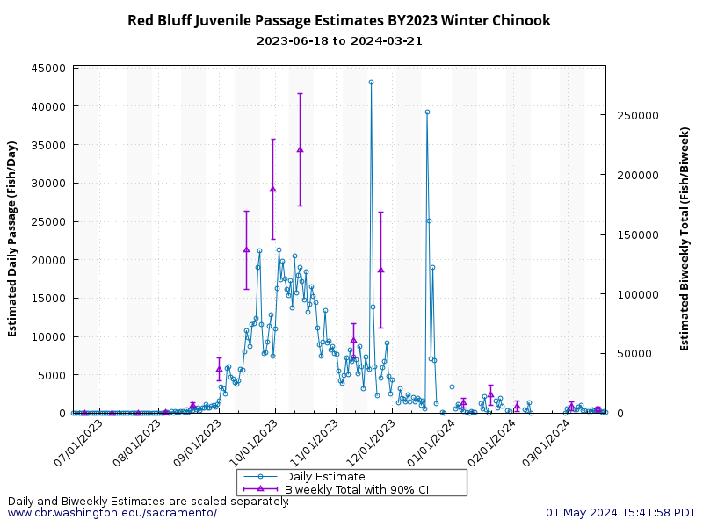

[Red Bluff Juvenile Passage Estimates Graph: SacPAS Central Valley Prediction & Assessment of Salmon (washington.edu)](https://www.cbr.washington.edu/sacramento/tmp/redbluffdaily_1714603318_94.html)

1. survival (STARS plots) (this is a surrogate for steelhead)

* Same as the plots for winter run (Figure 2)

1. minimization ((a) bar plots of totals (wild and hatchery), (b) annual cumulative loss by period and water year type)

(A1)

(A2)

(A3)

(B)

1. minimization (loss)

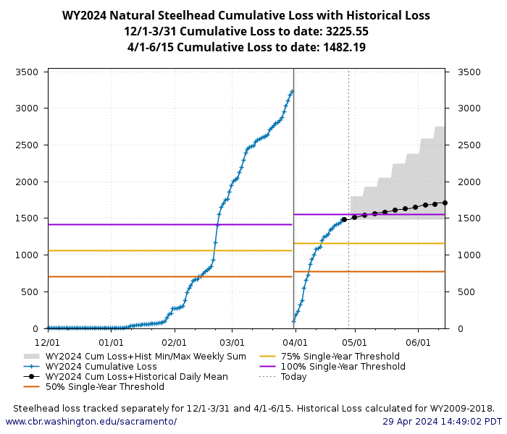

1. minimization (% of hatchery fish loss)

|  |  |  |  |  |
| --- | --- | --- | --- | --- |
| BroodYear | Total Hatchery Steelhead Release Number (BY) | Loss of clipped steelhead at the facilities (WY) | % Total Hatchery Release Number Lost to the Facilities | WaterYear |
| 2016 | 1,019,501 | 164.29 | 0.016 | 2017 |
| 2017 | 811,379 | 2,462.90 | 0.304 | 2018 |
| 2018 | 1,264,939 | 5,777.70 | 0.457 | 2019 |
| 2019 | 1,084,899 | 659.44 | 0.061 | 2020 |
| 2020 | 1,853,751 | 341.69 | 0.018 | 2021 |
| 2021 | 1,676,701 | 639.79 | 0.038 | 2022 |
| 2022 | 1,623,483 | 3,650.30 | 0.225 | 2023 |
| 2023 | 1,592,998 | 2,576.29 | 0.162 | 2024 |

1. minimization (daily loss and daily pumping rates)

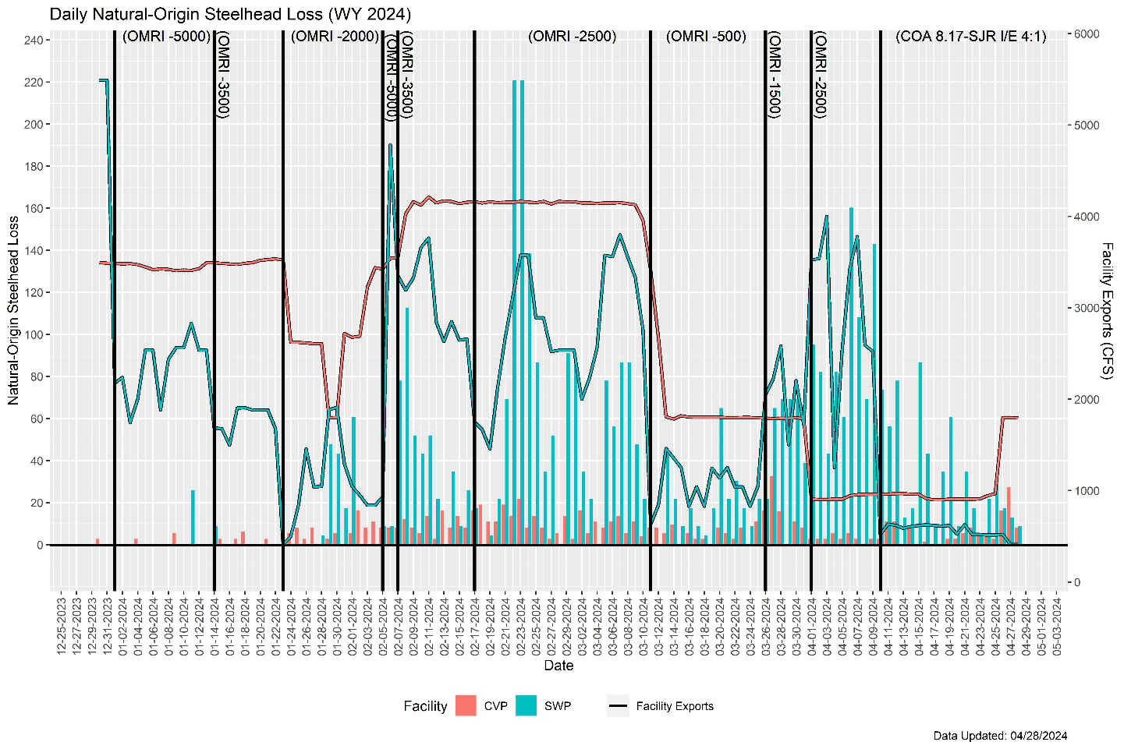

1. minimization (Tillotson seasonal predictions- weekly loss)

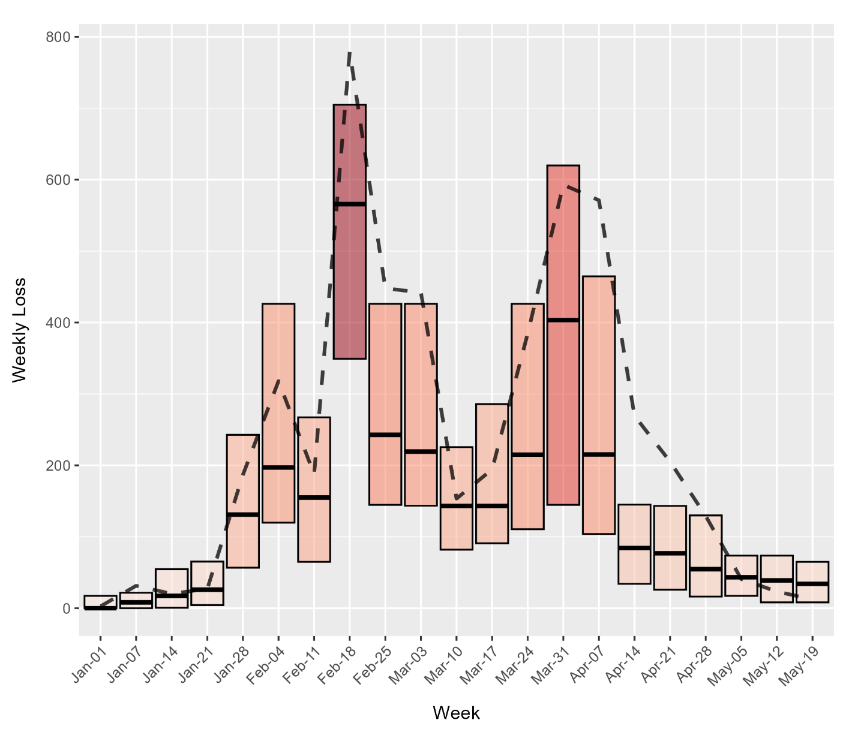

1. **Table comparing predicted and observed loss (hindcast)**

|  |  |  |  |  |  |  |
| --- | --- | --- | --- | --- | --- | --- |
| **Week** | **Average OMR** | **Average Exports** | **Average**  **San Joaquin Flow** | **Average Sacramento Flow** | **Predicted Weekly Loss Based on Columns to the left** | **Observed Loss** |
| 1/1 | 481 | 1570 | 4938 | 24037 | 116.95 | 8.20 |
| 1/8 | 0 | 2100 | 4938 | 24037 | 130.21 | 10.52 |
| 1/15 | -500 | 2650 | 4938 | 24037 | 171.27 | 16.01 |